(K8S) Kubernetes Task -02

- Create a Simple Pod Using YAML Task: Write a YAML file to create a Pod named firstpod with an nginx container. Verify the Pod creation using kubectl get pods and check the logs of the container using kubectl logs firstpod.
- Set Environment Variables in a Pod Task: Modify the YAML file to include environment variables myname: sabair and City: Hyderabad. Deploy the Pod and use kubectl exec <pod_name> -- env to check if the environment variables are set properly.
- Deploy a Pod with Commands (Args) in YAML Task: Modify the YAML file to add args that instruct the container to sleep for 50 seconds. Deploy the Pod and use kubectl describe pod to verify the args are correctly passed to the container.
- Create a Pod with Two Containers Task: Create a YAML file to define a Pod with two nginx containers inside. Use kubectl exec to access both containers and verify that both containers can communicate through the same network (e.g., using telnet between them).
- Set Up an Init Container in a Pod Task: Modify the YAML to include an init container that sleeps for 30 seconds before the main containers start. Verify the init container's execution using kubectl describe pod and check the logs to confirm its completion.
- Run a Dry Run Command to Generate YAML Task: Use the kubectl run nginx --image=nginx --dry-run=client -o yaml command to generate a Pod YAML definition. Modify the generated YAML to suit specific requirements (e.g., labels or environment variables) and deploy it.
- Use kubectl apply vs kubectl create Task: Create a YAML file to define a Pod. First, deploy it using kubectl create -f <file_name>.yml and then modify the YAML (e.g., change the image version). Use kubectl apply to redeploy and verify the difference between both commands.
- Edit an Existing Pod Configuration Task: Use kubectl edit pod <pod_name> to modify the running Pod's environment variables or image. After making the changes, verify if they took effect by checking the container logs or environment variables using kubectl exec.
- Expose a Pod Using a Service Task: Create a YAML file to expose your firstpod using a Service (ClusterIP). Ensure that your service is exposing the Pod on port 80 and verify it using kubectl get svc.
- Pod with Resource Limits and Requests Task: Add resource requests and limits to the containers in your YAML file. Specify CPU and memory requests/limits for both containers and deploy the Pod. Use kubectl describe pod to verify if the resource configurations are correctly applied.

- Insatll YAML Extension in VS CODE for Correction of Syntax Error

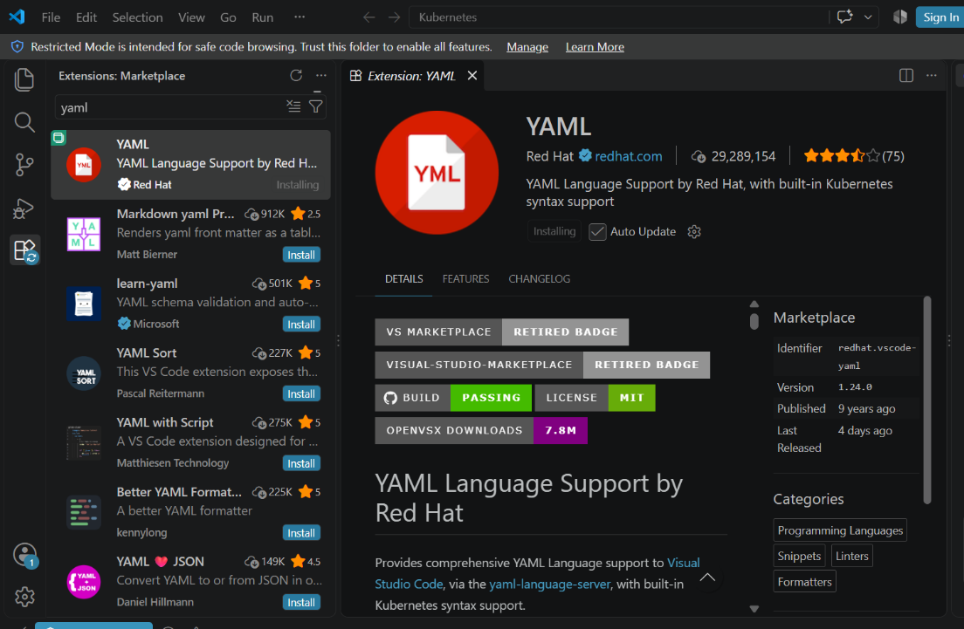

Vs code Extension YAML
Select YAML Settings Click on (Edit in Settings.json) Past this script
{
"yaml.schemas": {
"kubernetes": "*.yaml"
},
"yaml.customTags": [],
"python": {
"editor.formatOnType": true
}
}
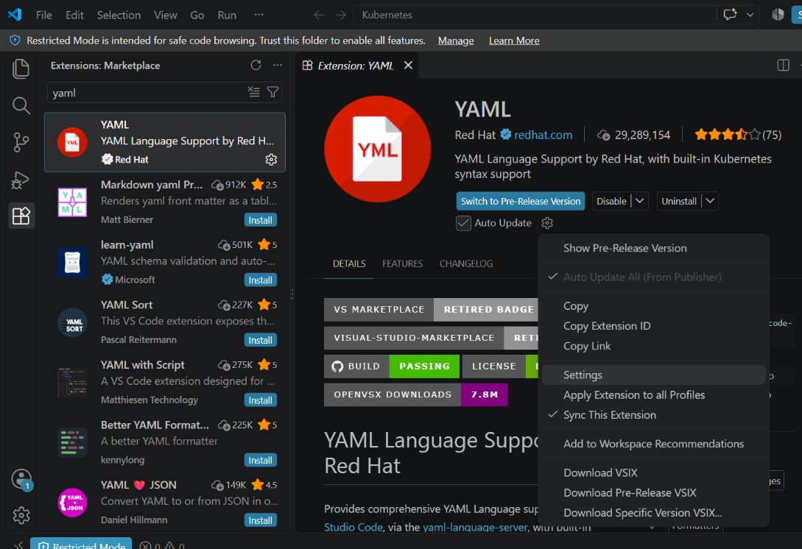
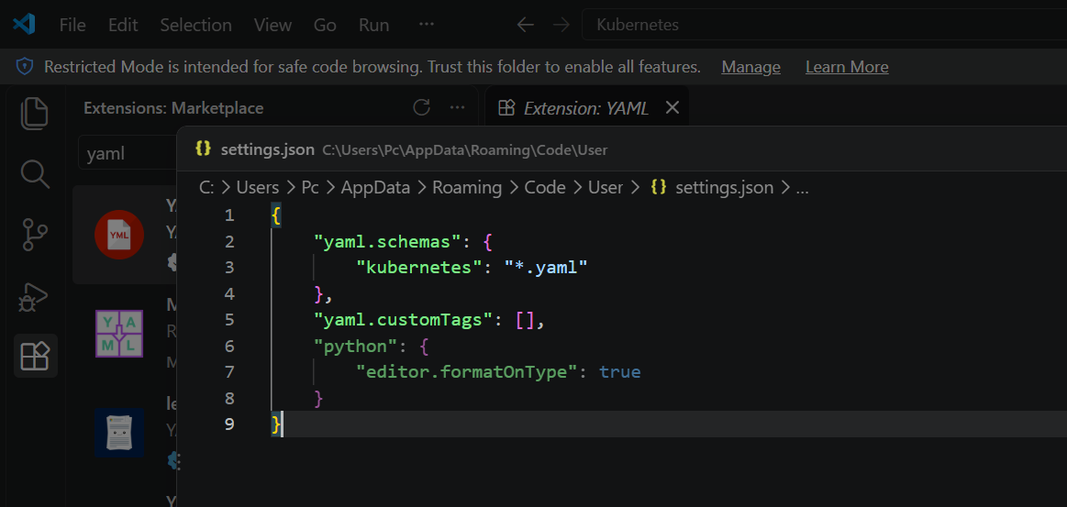

- Create a Simple Pod Using YAML Task: Write a YAML file to create a Pod named firstpod with an nginx container. Verify the Pod creation using kubectl get pods and check the logs of the container using kubectl logs firstpod.

1. Create a YAML file
Open your project folder in VS Code.
Create a file:
$ vi Sarfaraz.yaml
Put this inside:

apiVersion: v1
kind: Pod

metadata:
name: firstpod
labels:
env: prod

spec:
containers:
- name: test
image: nginx
Save the file.
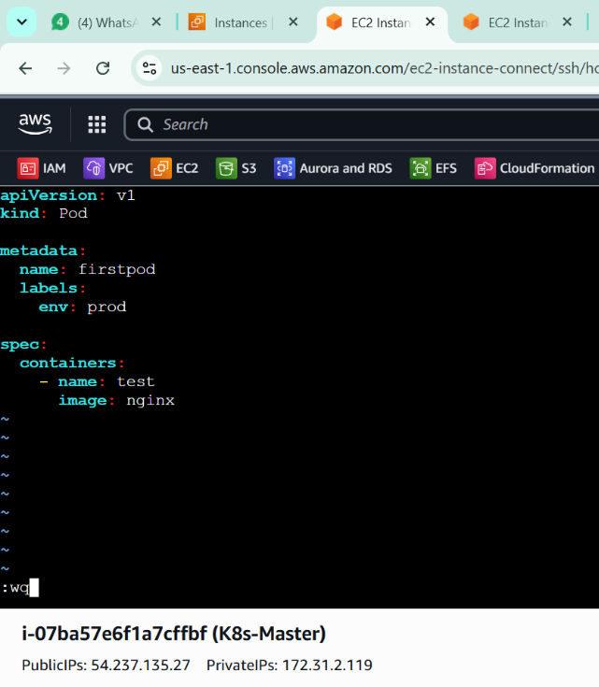

2. Check the YAML file
Open the VS Code Terminal:
Terminal → New Terminal
Run:
$ cat firstpod.yaml
You should see the YAML content.
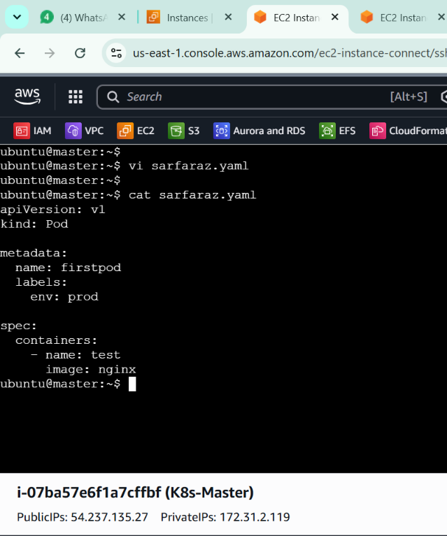

3. Create the Pod
Run:
$ kubectl apply -f firstpod.yaml
Expected output:
pod/firstpod created
If it says:
pod/firstpod unchanged
the Pod already exists.
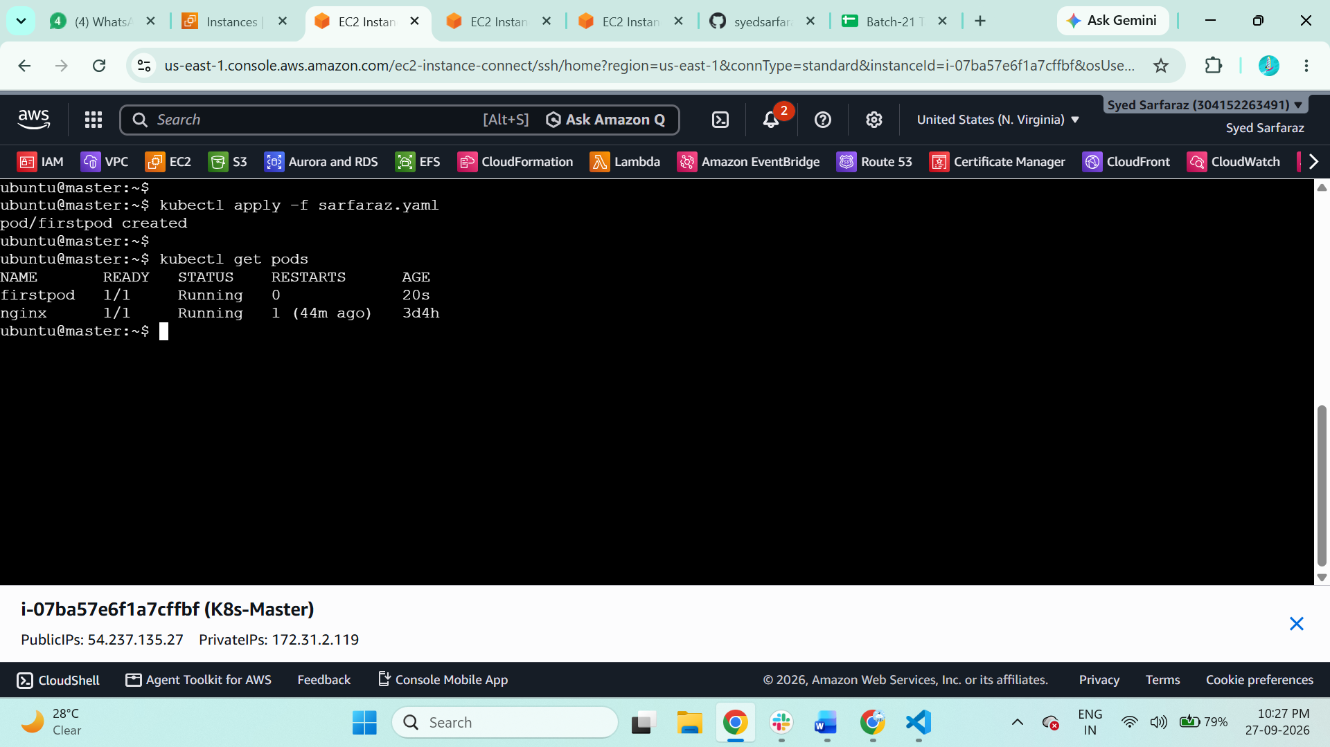

4. Verify the Pod
Run:
$ kubectl get pods
You should get something similar to:
NAME READY STATUS RESTARTS AGE
firstpod 1/1 Running 0 10s
The important part is:
firstpod 1/1 Running

5. Get detailed Pod information
Run:
$ kubectl describe pod firstpod
This shows the Pod details, including:
- Pod name
- Container name
- Nginx image
- Pod IP
- Node
- Events
- Container status
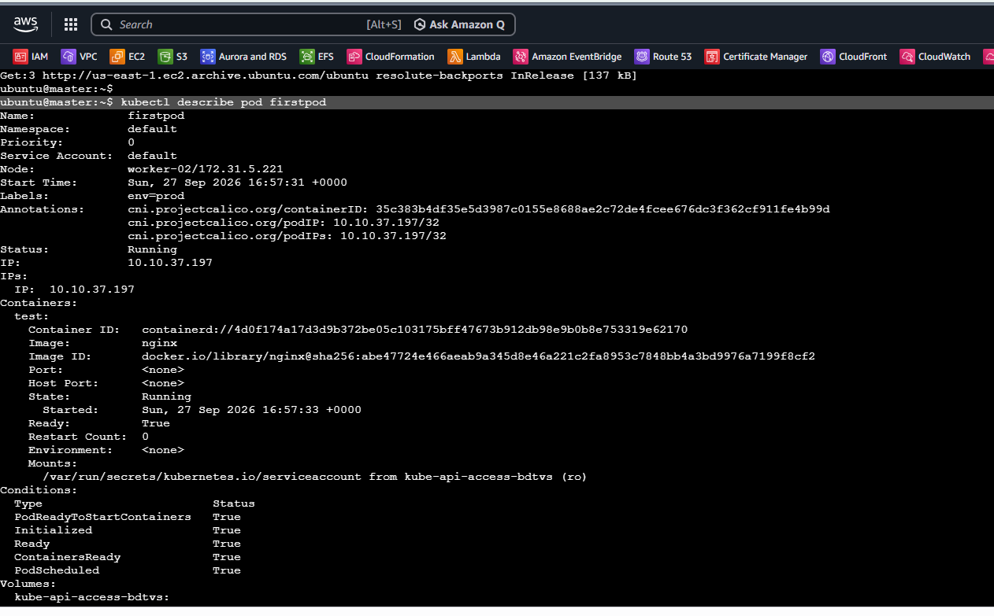

6. Check the Nginx container logs
Run exactly as required in your task:
$ kubectl logs firstpod
You should see Nginx-related startup logs, for example:
/docker-entrypoint.sh: ...
Starting nginx
The exact log output can vary depending on the Nginx image version.
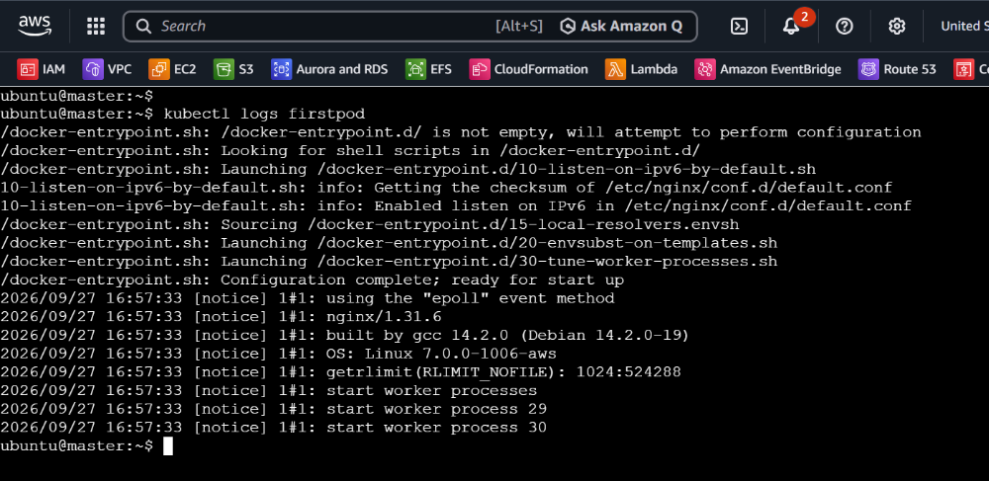

7. Optional: Confirm the container image
Run:
kubectl get pod firstpod -o wide
Or:
kubectl get pod firstpod -o jsonpath='{.spec.containers[0].image}'
Expected:
nginx:latest
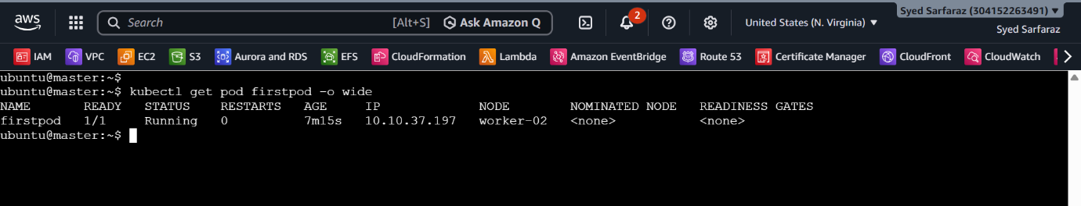

- Set Environment Variables in a Pod Task: Modify the YAML file to include environment variables myname: sabair and City: Hyderabad. Deploy the Pod and use kubectl exec <pod_name> -- env to check if the environment variables are set properly.

You can modify your existing firstpod.yaml.
1. Update Sarfaraz.yaml
Use this complete YAML:

apiVersion: v1
kind: Pod

metadata:
name: firstpod
labels:
env: prod
name: sarfaraz

spec:
containers:
- name: nginx
image: nginx
env:
- name: myname
value: "sarfaraz"

- name: city
value: "Hyderabad"
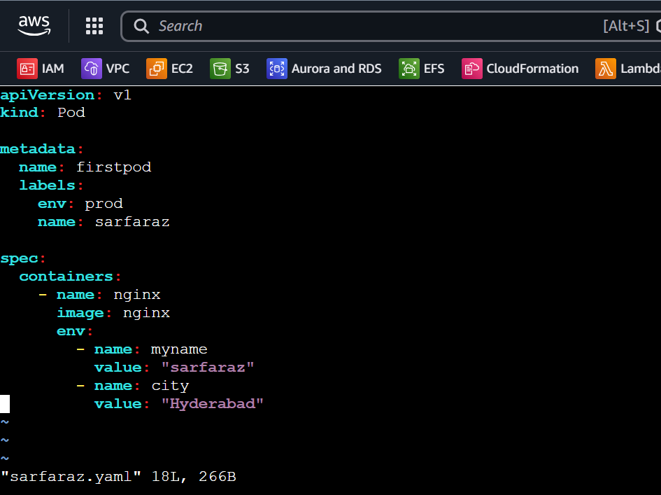

2. Save the file
Save as:
$ Sarfaraz.yaml

3. Apply the YAML
Run:
$ kubectl apply -f Sarfaraz.yaml

You may get:
pod/firstpod configured
Important: Kubernetes does not allow changing the container env of an existing Pod in place in many cases. If you get an error, delete the old Pod first:

$ kubectl delete pod firstpod
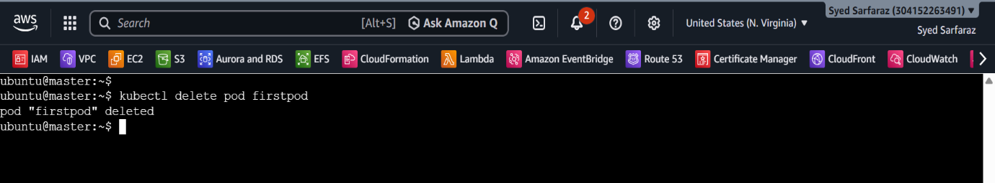
Then create it again:
$ kubectl apply -f firstpod.yaml
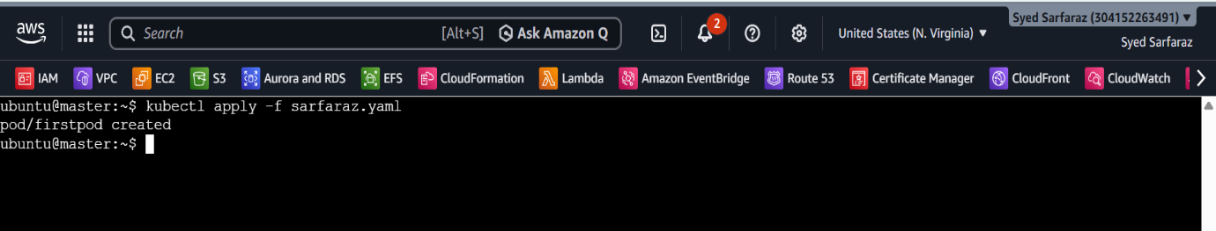

4. Verify the Pod
$ kubectl get pods
You should see:
NAME READY STATUS RESTARTS AGE
firstpod 1/1 Running 0 ...
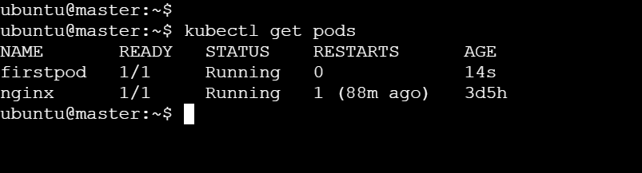

5. Check the environment variables
Run the exact command required by your task:
$ kubectl exec firstpod -- env
Look through the output for:
myname=sarfaraz
City=Hyderabad
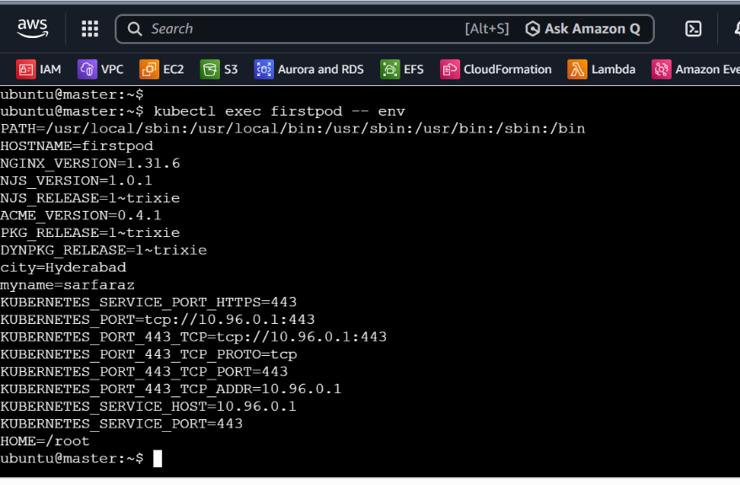

6. Easier verification
You can check only the two variables:
$ kubectl exec firstpod -- env | grep -E 'myname|City'
Expected:
myname=sarfaraz
City=Hyderabad

- Deploy a Pod with Commands (Args) in YAML Task: Modify the YAML file to add args that instruct the container to sleep for 50 seconds. Deploy the Pod and use kubectl describe pod to verify the args are correctly passed to the container.

Step 1 — Edit sarfaraz.yaml
Open the file:
vi sarfaraz.yaml
Use this YAML:

apiVersion: v1
kind: Pod

metadata:
name: firstpod
labels:
env: prod
name: sarfaraz

spec:
containers:
- name: nginx
image: busybox

command:
- "sleep"

args:
- "50"

env:
- name: myname
value: "sarfaraz"

- name: city
value: "Hyderabad"
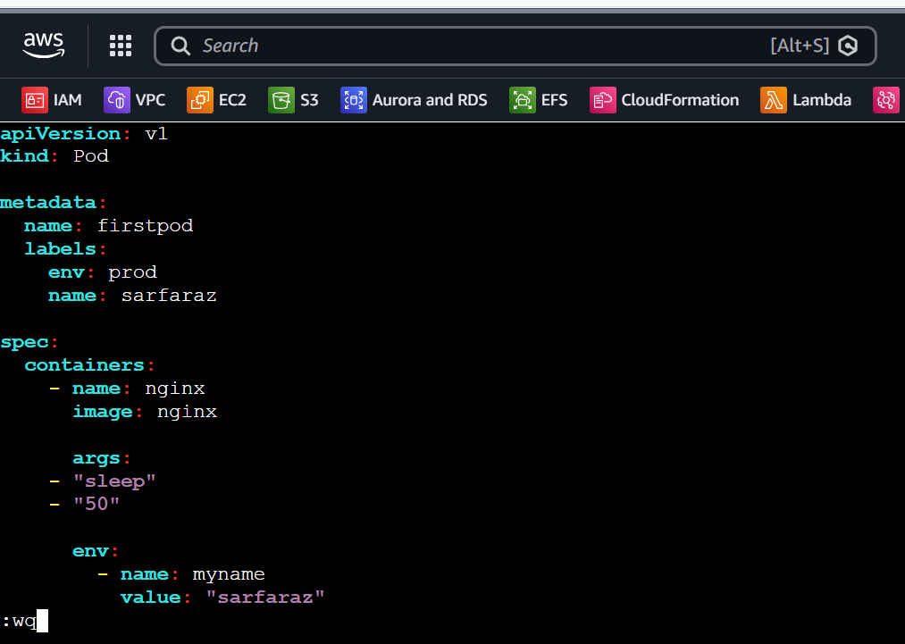

Step 2 — Save the file
If you're using vi:
ESC
:wq
ENTER

Step 3 — If you want to see it running
Delete the completed Pod:
$ kubectl delete pod firstpod
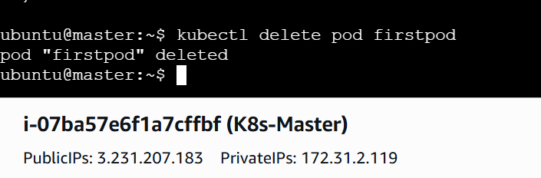

Step 4 — Apply the Pod
Run:
$ kubectl apply -f sarfaraz.yaml
Expected:
pod/firstpod created
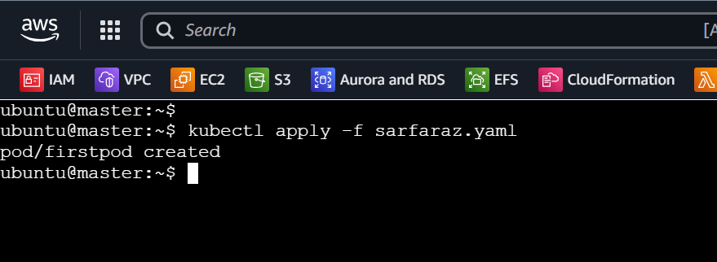

Step 5 — Check the Pod
Immediately run:
$ kubectl get pod firstpod

You may see:
NAME READY STATUS RESTARTS
firstpod 0/1 ContainerCreating 0
Because the container only sleeps for 50 seconds, it will eventually finish.
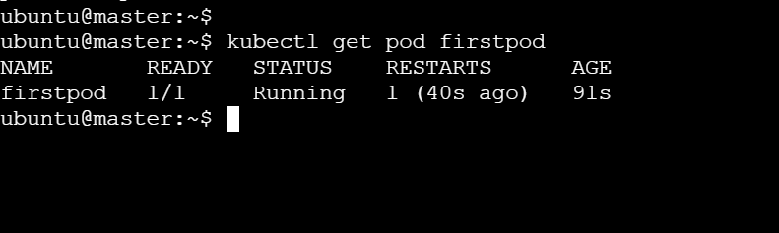

Step 6 — Verify the Args with describe
This is the main requirement of your task.
Run:
kubectl describe pod firstpod
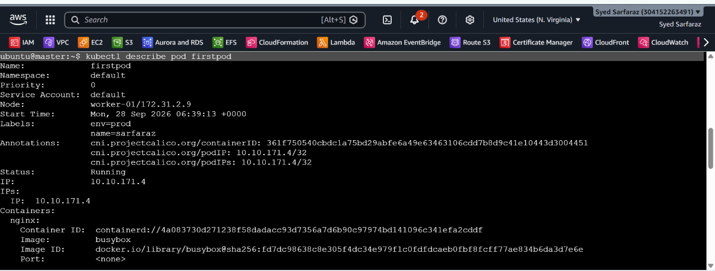

Step 7 — Check the Pod status
Run:
kubectl get pod firstpod
After approximately 50 seconds, you may see:
firstpod 0/1 Completed
That's expected because sleep 50 finishes after 50 seconds.

Step 8 — If you want to see it running
$ kubectl get pod firstpod -w
You should see it running for around 50 seconds and then changing to:
Completed
Press:
Ctrl + C
to stop watching.

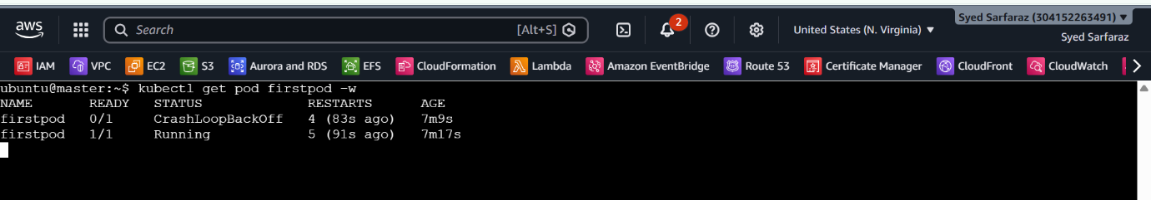

- Create a Pod with Two Containers Task: Create a YAML file to define a Pod with two nginx containers inside. Use kubectl exec to access both containers and verify that both containers can communicate through the same network (e.g., using telnet between them).

- Create the YAML file
$ sudo vi sarfaraz.yaml

apiVersion: v1
kind: Pod

metadata:
name: firstpod

spec:
containers:
- name: firstcontainer
image: nginx

- name: secondcontainer
image: nginx
command: ["/bin/sh", "-c"]
args:
- |
sed -i 's/listen 80;/listen 8080;/' /etc/nginx/conf.d/default.conf
nginx -g 'daemon off;'

Save:
Esc
:wq
Enter
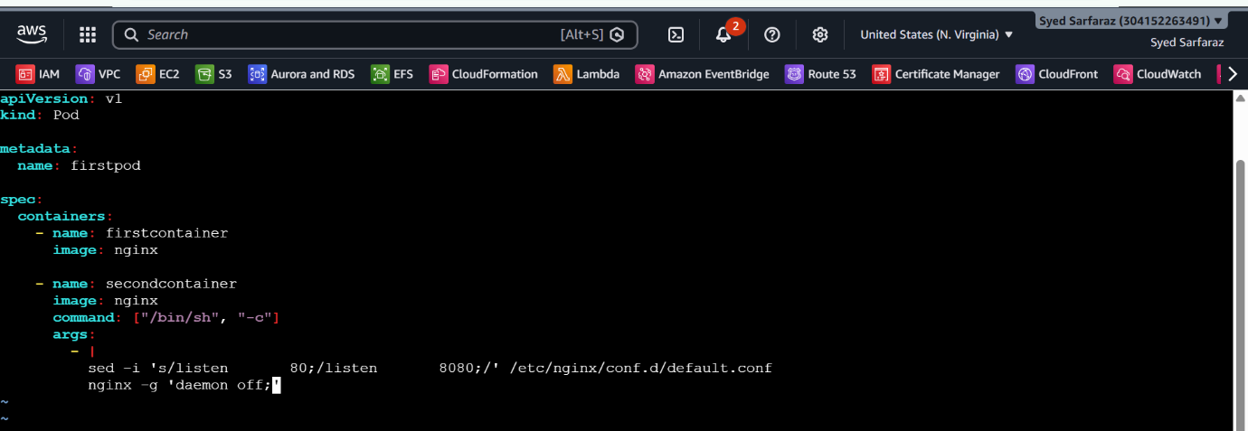

2. Delete the old Pod
kubectl delete pod firstpod
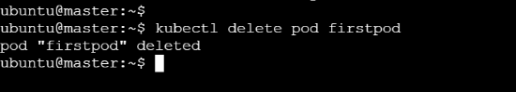

3. Create the new Pod
kubectl apply -f sarfaraz.yaml
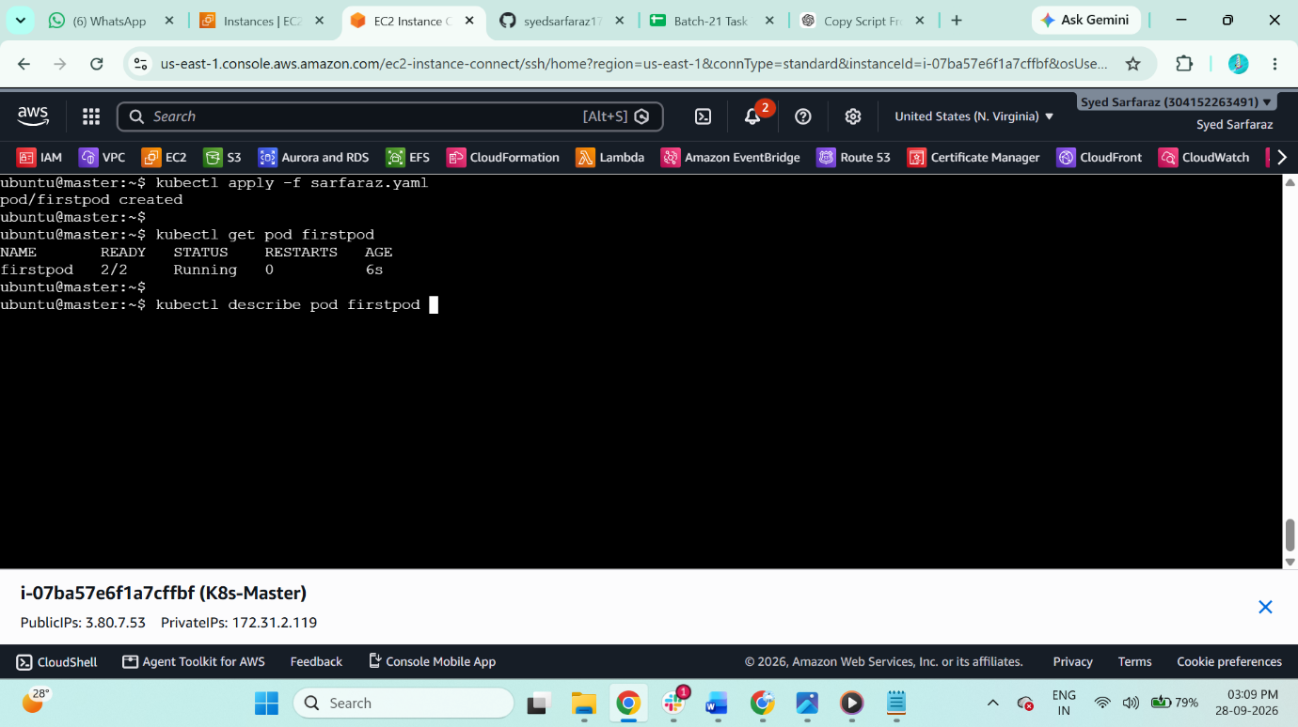

4. Check
kubectl get pod firstpod -o wide
You should now get:
firstpod 2/2 Running

5. Verify both containers have the same IP
kubectl exec firstpod -c firstcontainer -- hostname -i
kubectl exec firstpod -c secondcontainer -- hostname -i
Both should return the same Pod IP, for example:
10.10.171.xx
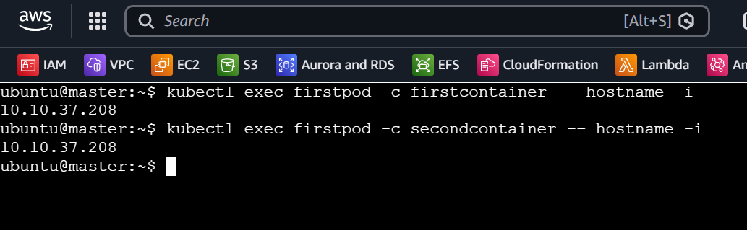

6. Test communication
From firstcontainer, test the second nginx on port 8080:
kubectl exec firstpod -c firstcontainer -- curl http://localhost:8080
You should receive an HTML nginx welcome page.
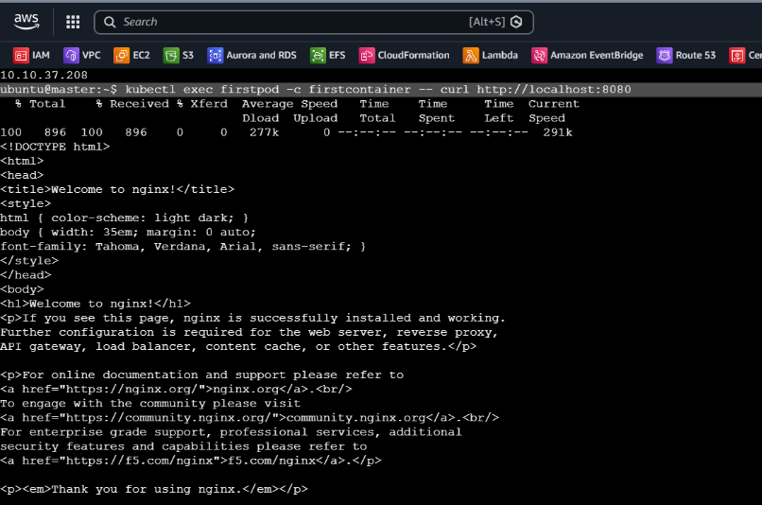

5. Access the first container
kubectl exec -it two-nginx -c nginx1 -- /bin/bash
Exit:
Exit
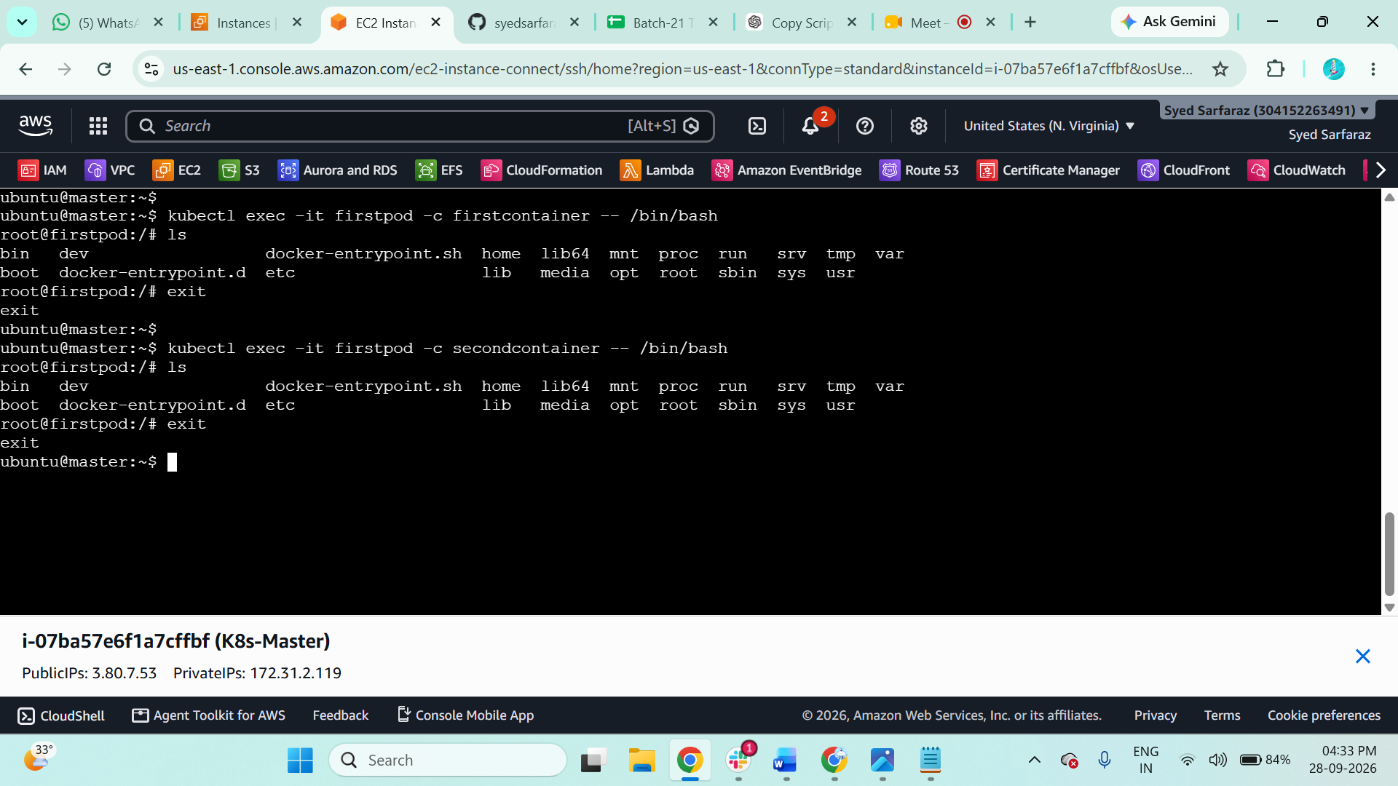

6. Access the second container
kubectl exec -it two-nginx -c nginx2 -- /bin/bash
Exit:
Exit

- Set Up an Init Container in a Pod Task: Modify the YAML to include an init container that sleeps for 30 seconds before the main containers start. Verify the init container's execution using kubectl describe pod and check the logs to confirm its completion.

1. Edit your YAML
$ sudo vi sarfaraz.yaml
Use:

apiVersion: v1
kind: Pod

metadata:
name: firstpod

spec:
initContainers:
- name: init-container
image: busybox
command: ["sh", "-c"]
args:
- echo "Init container started";
sleep 30;
echo "Init container completed";

containers:
- name: firstcontainer
image: nginx

- name: secondcontainer
image: nginx
command: ["/bin/sh", "-c"]
args:
- |
sed -i 's/listen 80;/listen 8080;/' /etc/nginx/conf.d/default.conf
nginx -g 'daemon off;'
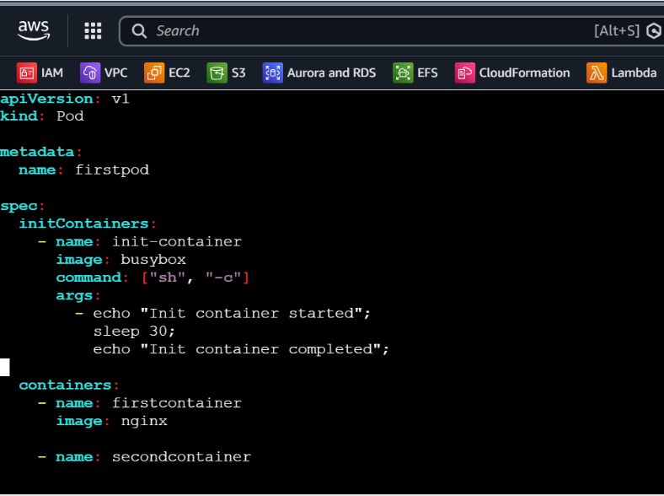

2. Delete the old Pod
$ kubectl delete pod firstpod
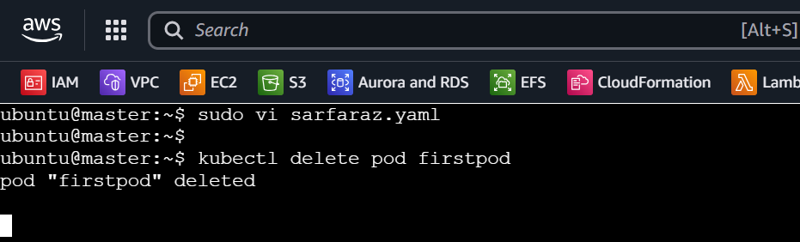

3. Create the Pod
$ kubectl apply -f sarfaraz.yaml
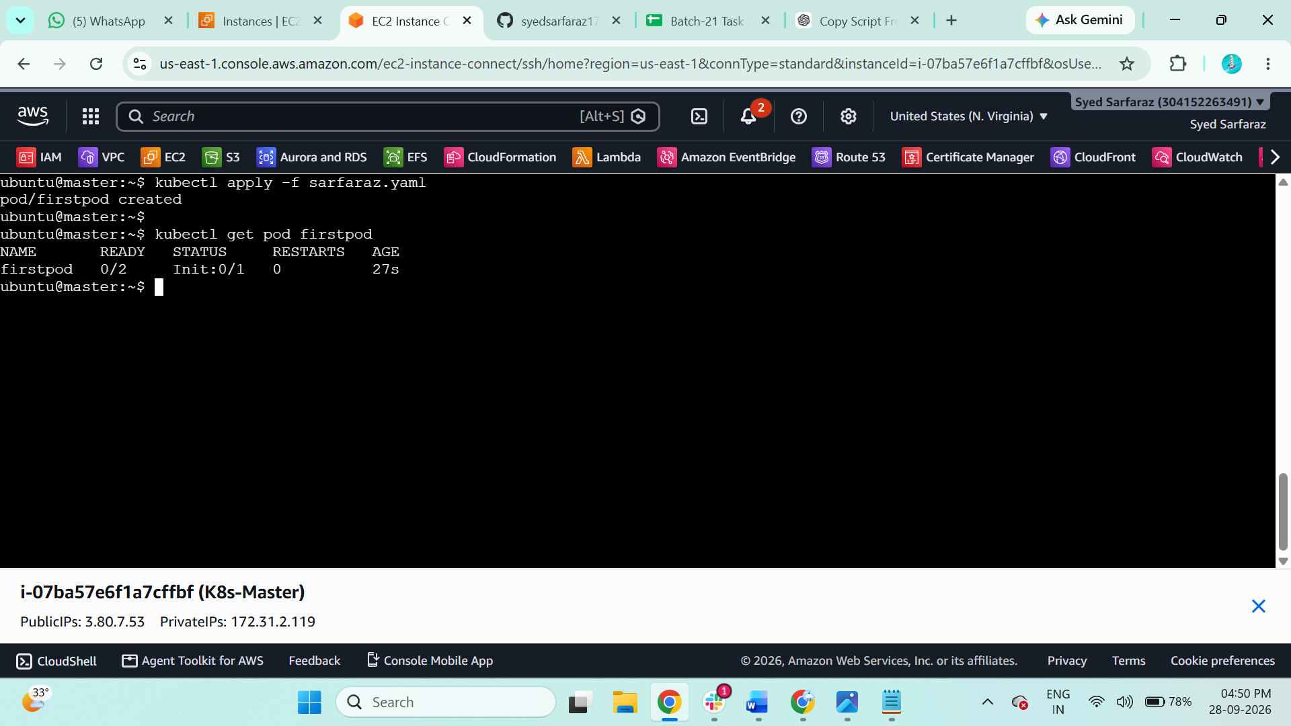

4. Check the Pod
Immediately run:
$ kubectl get pod firstpod
During the 30 seconds, you should see something like:
0/2 Init:0/1
After the init container finishes:
2/2 Running

5. Verify Init Container with describe
kubectl describe pod firstpod
Look for:
Init Containers:
init-container:
State: Terminated
Reason: Completed
Exit Code: 0
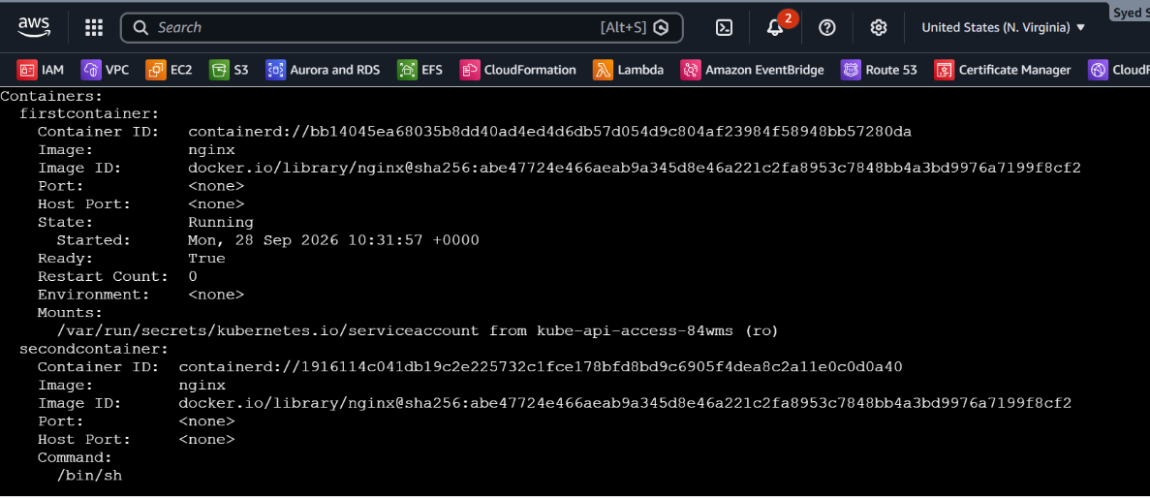
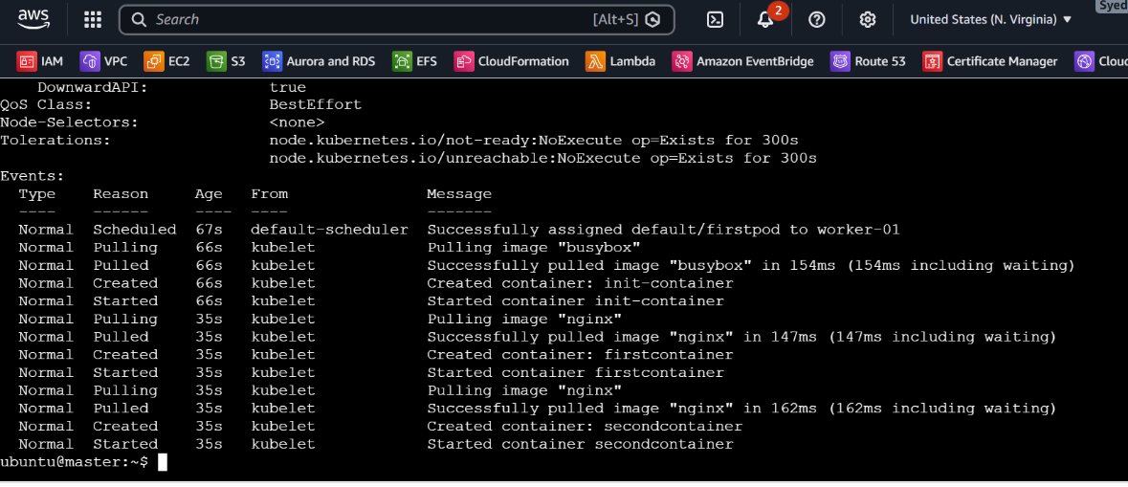

6. Check Init Container logs
kubectl logs firstpod -c init-container
Expected:
Init container started
Init container completed
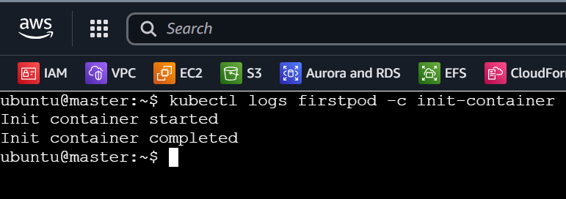

7. Final verification
$ kubectl get pod firstpod
Expected:
$ firstpod 2/2 Running
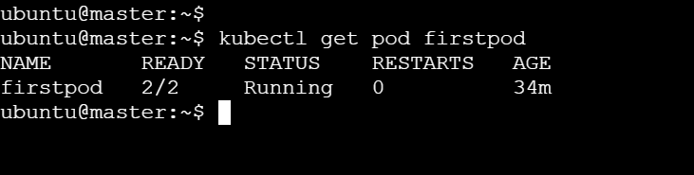

- Run a Dry Run Command to Generate YAML Task: Use the kubectl run nginx --image=nginx --dry-run=client -o yaml command to generate a Pod YAML definition. Modify the generated YAML to suit specific requirements (e.g., labels or environment variables) and deploy it.

1. Generate the Pod YAML using dry run
Run:
kubectl run nginx --image=nginx --dry-run=client -o yaml > nginx.yaml
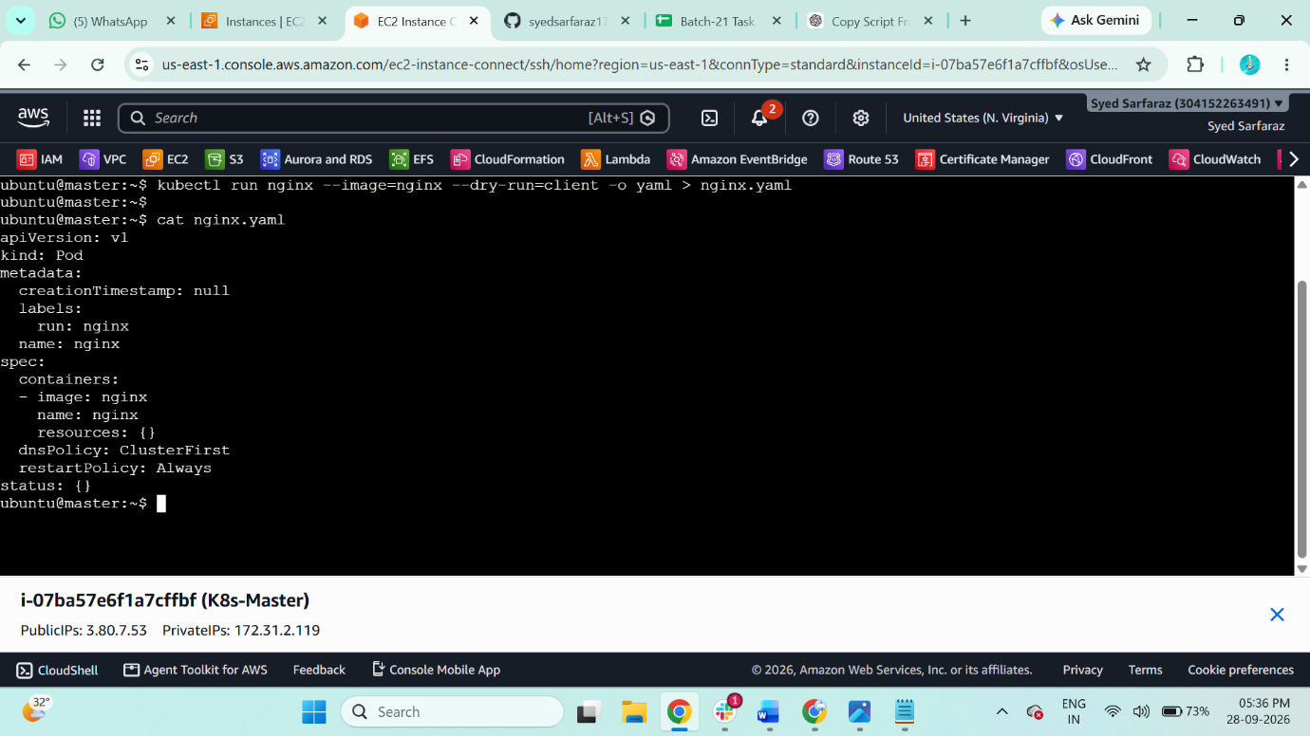

2. Check the generated YAML
cat nginx.yaml

3. Edit the YAML
sudo vi nginx.yaml

Modify it to add labels and environment variables:

apiVersion: v1
kind: Pod
metadata:
name: nginx
labels:
env: prod
app: nginx
spec:
containers:
- name: nginx
image: nginx
env:
- name: myname
value: "sarfaraz"
- name: city
value: "Hyderabad"
Save:
Esc
:wq
Enter
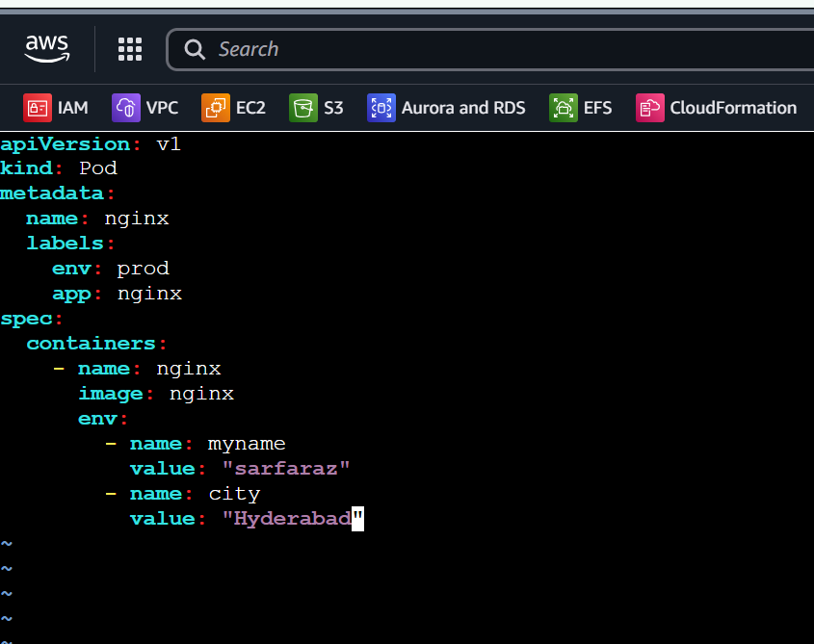

4. Deploy the generated/modified YAML
kubectl apply -f nginx.yaml
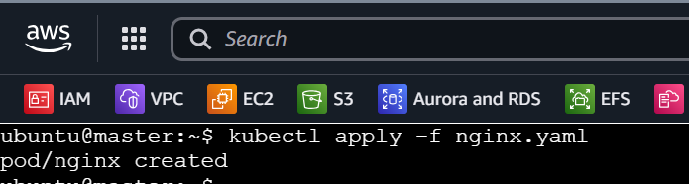

5. Verify the Pod
kubectl get pod nginx
Expected:
nginx 1/1 Running
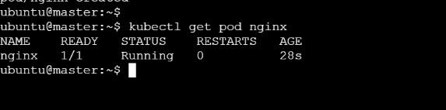

6. Verify the labels
kubectl get pod nginx --show-labels
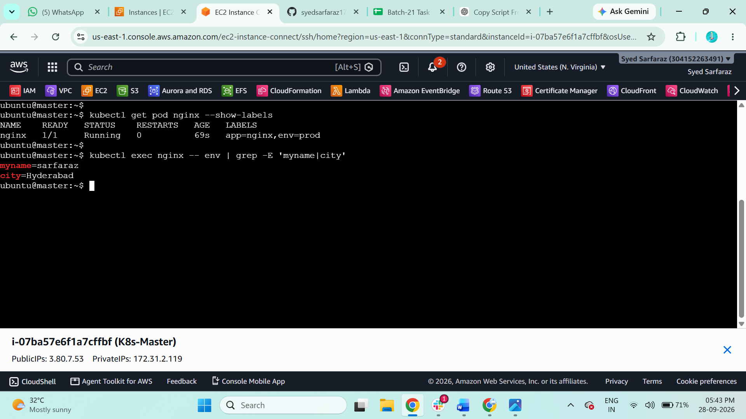

7. Verify environment variables
kubectl exec nginx -- env | grep -E 'myname|city'
Expected:
myname=sarfaraz
city=Hyderabad

8. Final verification
kubectl describe pod nginx
Check that the Labels and Environment sections contain your changes.
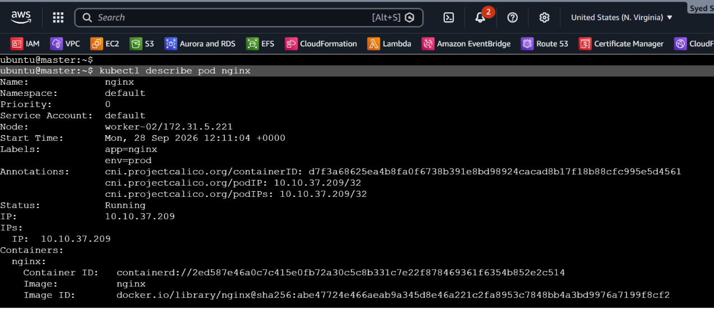
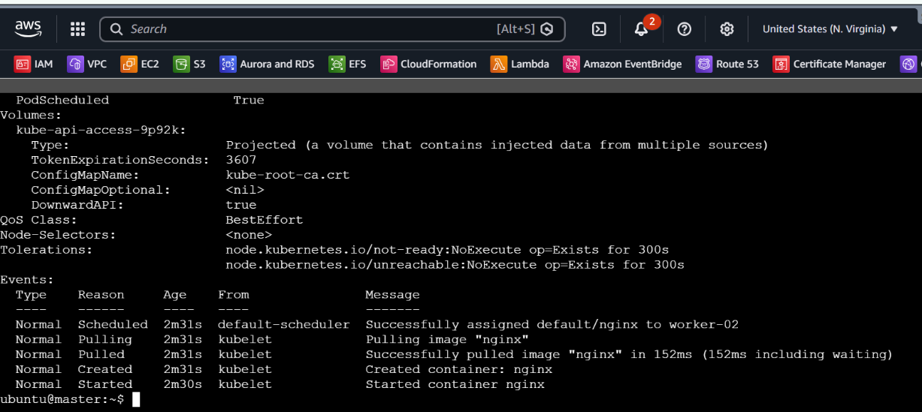

- Use kubectl apply vs kubectl create Task: Create a YAML file to define a Pod. First, deploy it using kubectl create -f <file_name>.yml and then modify the YAML (e.g., change the image version). Use kubectl apply to redeploy and verify the difference between both commands.

1. Create the YAML file
sudo vi create-pod.yaml
Add:
apiVersion: v1
kind: Pod

metadata:
name: create-pod
labels:
app: nginx

spec:
containers:
- name: nginx
image: nginx:1.26
Save:
Esc
:wq
Enter
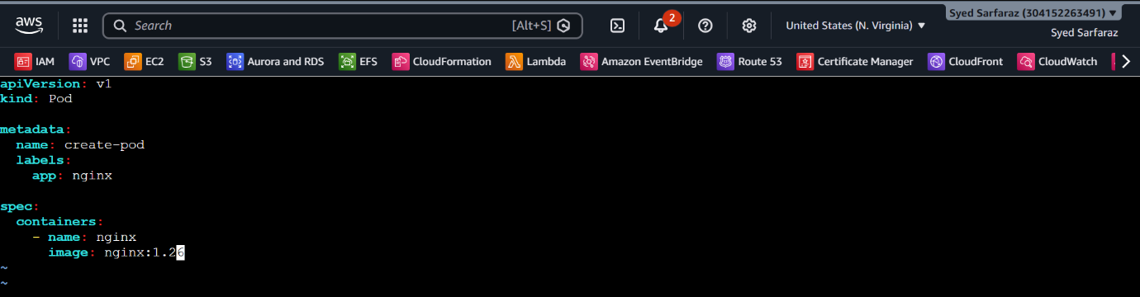

2. Deploy using kubectl create
kubectl create -f create-pod.yaml
Expected:
pod/create-pod created
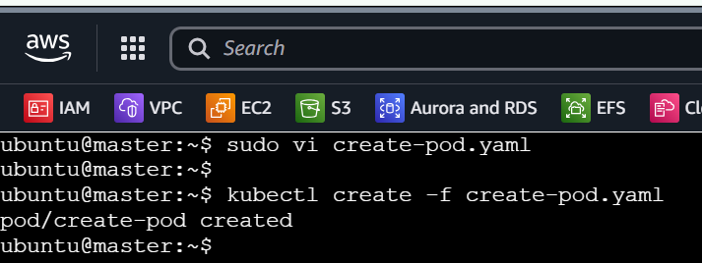

3. Verify the Pod
kubectl get pod create-pod
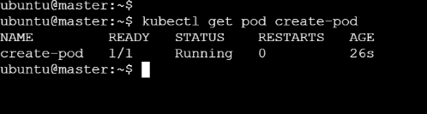

Check the image:
kubectl describe pod create-pod | grep -i image
You should see:
Image: nginx:1.26
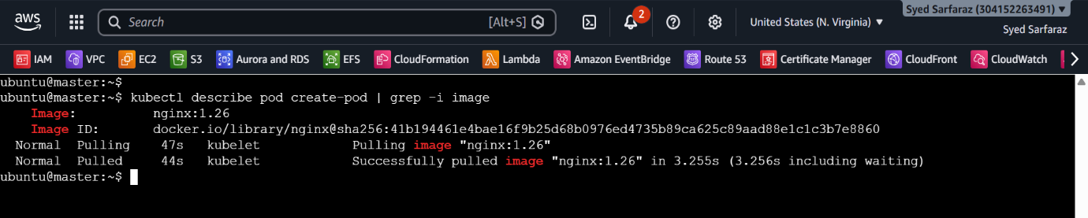

4. Modify the YAML
sudo vi create-pod.yaml

Change:
image: nginx:1.26
to:
image: nginx:1.27

Save:
Esc
:wq
Enter
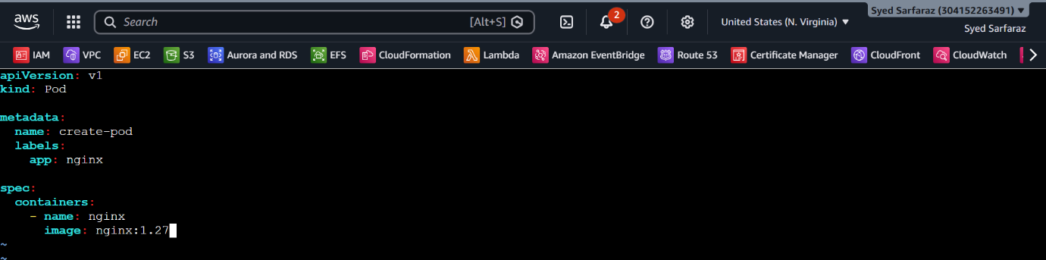

5. Check the result
kubectl describe pod create-pod | grep -i image
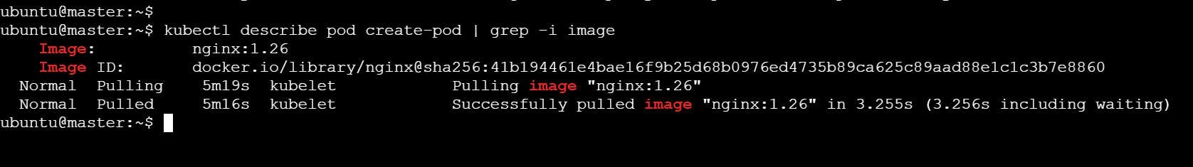

6. Demonstrate the difference
Try creating the same YAML again:
kubectl create -f create-pod.yaml
You should get:
Error from server (AlreadyExists): pods "create-pod" already exists
Whereas:
kubectl apply -f create-pod.yaml
is designed to create the resource if it doesn't exist and update the declared configuration when it does.
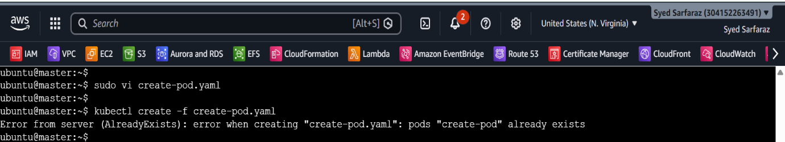

7. Use kubectl apply
kubectl apply -f create-pod.yaml
You will likely get an error because Pod container image can be changed, but this exercise is intended to demonstrate that create and apply behave differently.
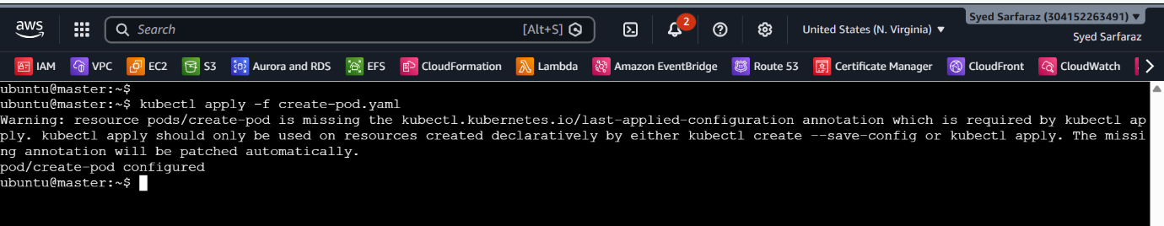

- Edit an Existing Pod Configuration Task: Use kubectl edit pod <pod_name> to modify the running Pod's environment variables or image. After making the changes, verify if they took effect by checking the container logs or environment variables using kubectl exec.

1. Check the existing Pod
Use your existing Pod:
kubectl get pod create-pod
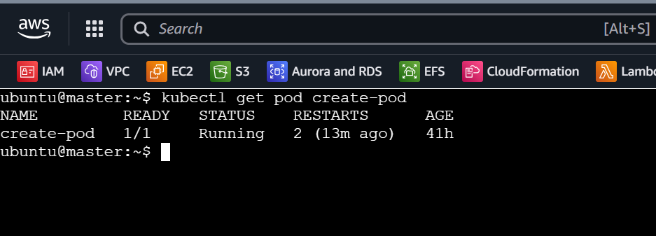

2. Edit the Pod
For the assignment, you can instead edit a mutable field such as the container image:
$ kubectl edit pod create-pod
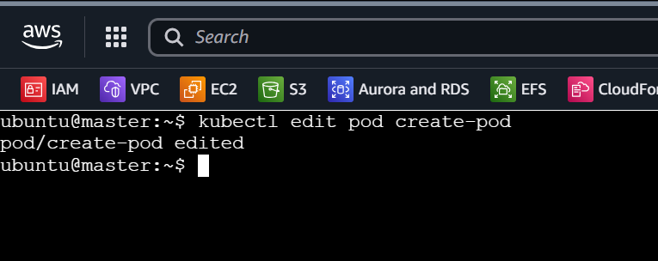
Change:
image: nginx:1.27
to:
image: nginx:1.28

Save and exit:
Esc
:wq
Enter
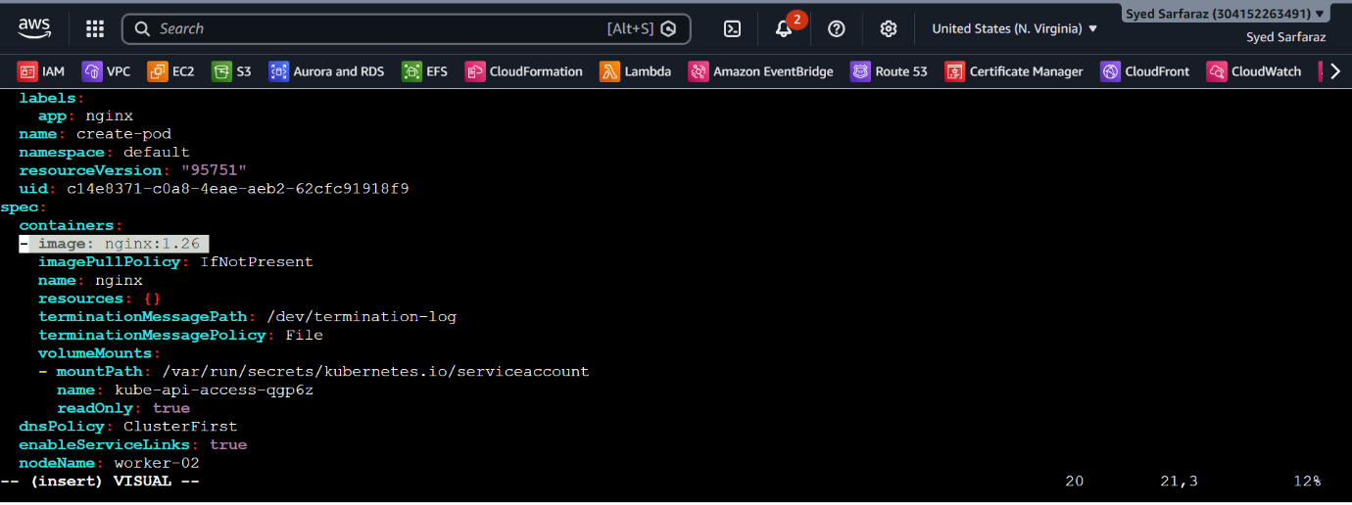

3. Verify the image
$ kubectl describe pod create-pod | grep -i image
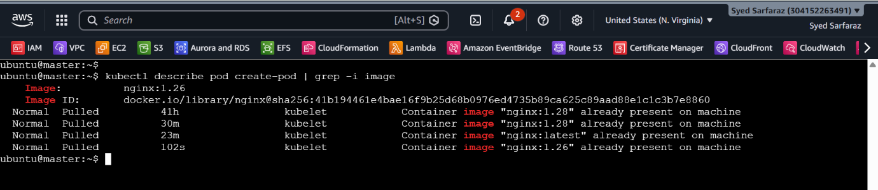
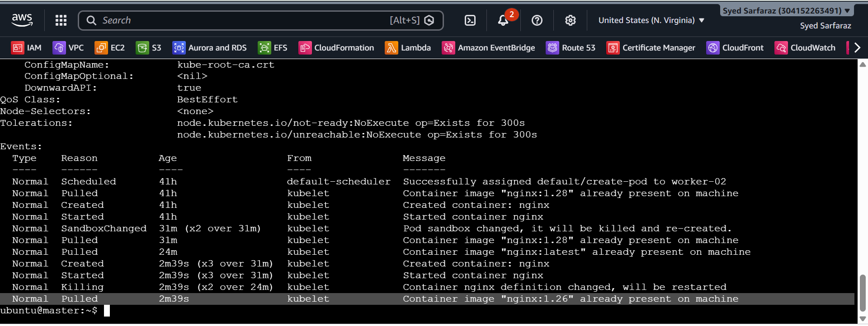

4. Verify using kubectl exec
kubectl exec create-pod -- nginx -v
You should see the running nginx version.
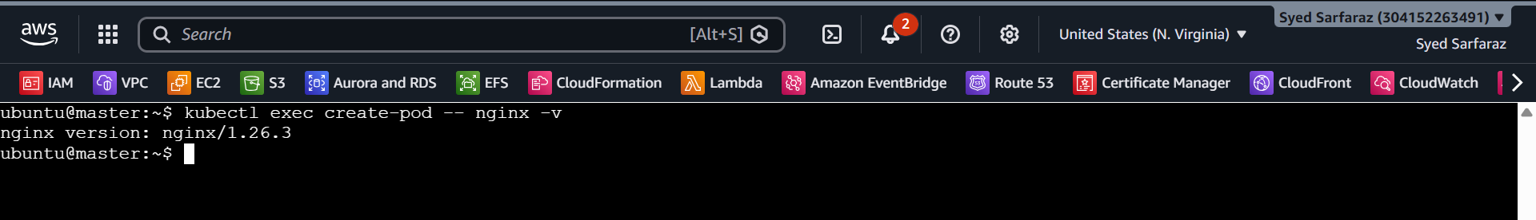

5. Final check
kubectl get pod create-pod
Expected:
create-pod 1/1 Running
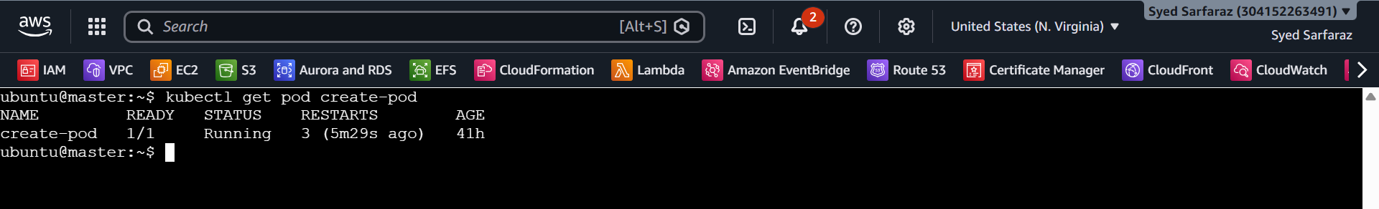

- Expose a Pod Using a Service Task: Create a YAML file to expose your firstpod using a Service (ClusterIP). Ensure that your service is exposing the Pod on port 80 and verify it using kubectl get svc.

1. Check your Pod labels
kubectl get pod nginx --show-labels
If your Pod has:
app=nginx,env=prod
use that label in the Service.
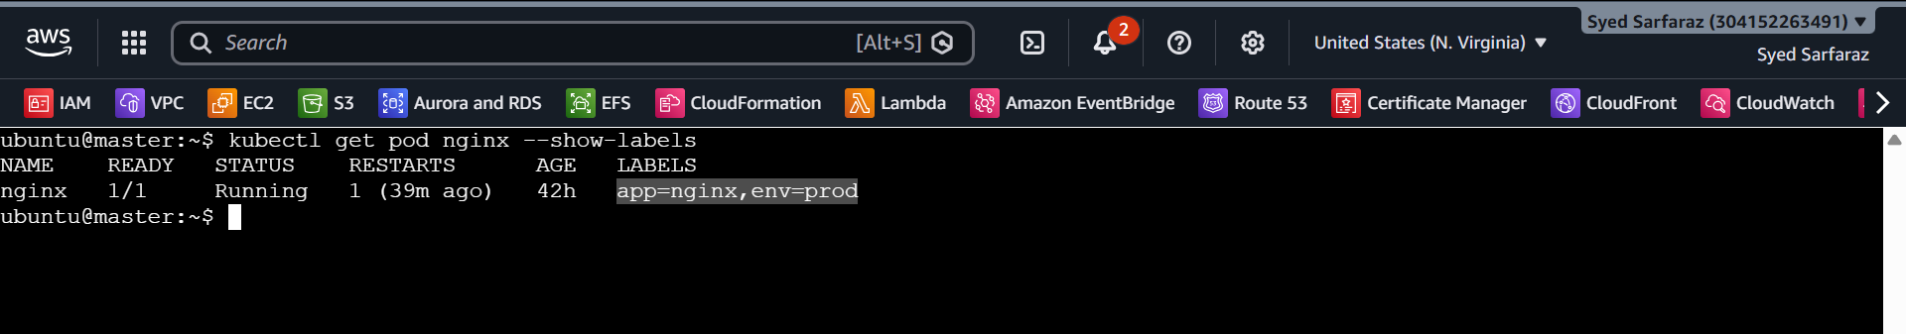

2. Create the Service YAML
sudo vi nginx.yaml

Add:
apiVersion: v1
kind: Service

metadata:
name: firstpod-service

spec:
type: ClusterIP
selector:
app: nginx
ports:
- port: 80
targetPort: 80
Save:
Esc
:wq
Enter
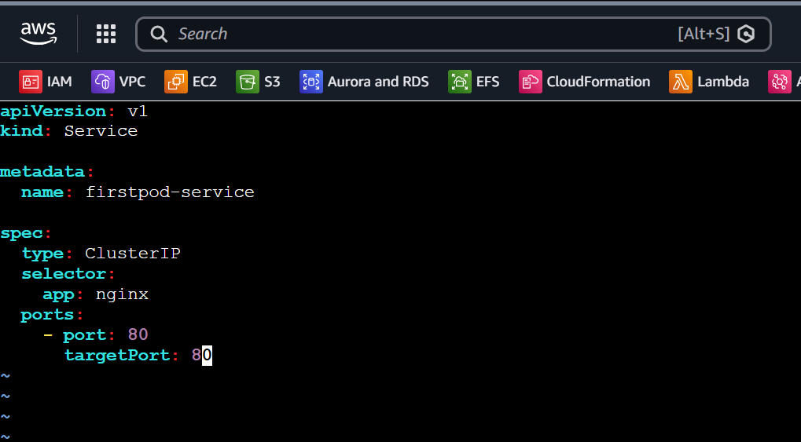

3. Create the Service
kubectl apply -f nginx.yaml
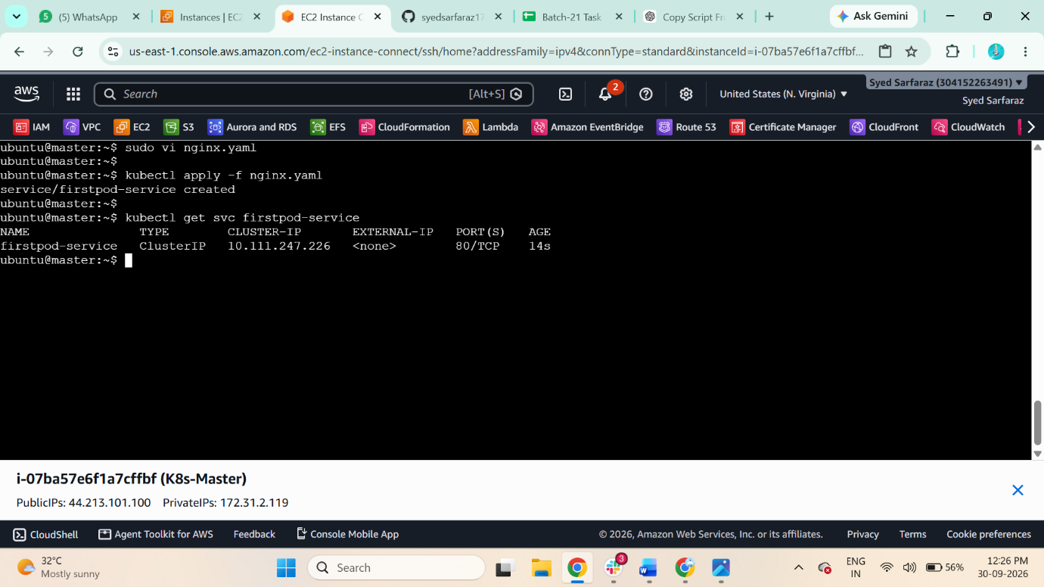

4. Verify the Service
kubectl get svc firstpod-service
You should see:
firstpod-service ClusterIP ... 80/TCP

5. Verify the Service endpoints
kubectl get endpoints firstpod-service
You should see your firstpod Pod IP with port 80.
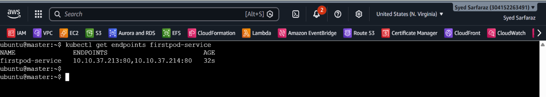

6. Final check
kubectl describe svc firstpod-service
Confirm:
Type: ClusterIP
Port: 80
TargetPort: 80
Endpoints: <firstpod-IP>:80
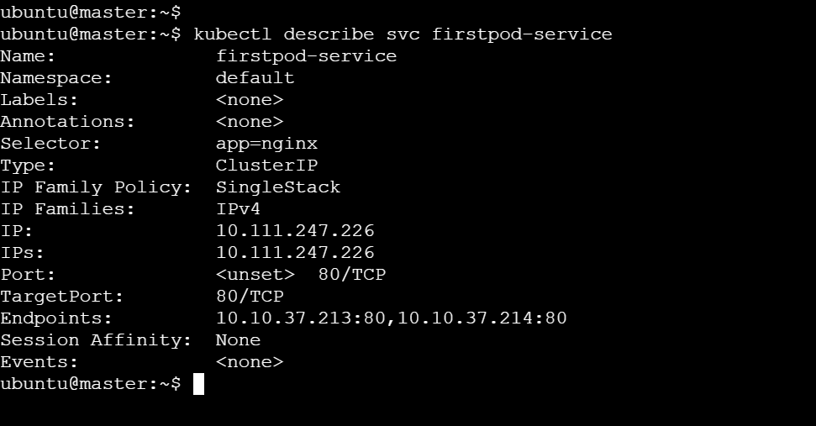

- Pod with Resource Limits and Requests Task: Add resource requests and limits to the containers in your YAML file. Specify CPU and memory requests/limits for both containers and deploy the Pod. Use kubectl describe pod to verify if the resource configurations are correctly applied.

1. Edit your Pod YAML
sudo vi sarfaraz.yaml

Use this structure for both containers:
apiVersion: v1
kind: Pod

metadata:
name: firstpod

spec:
containers:
- name: firstcontainer
image: nginx
resources:
requests:
cpu: "100m"
memory: "128Mi"
limits:
cpu: "200m"
memory: "256Mi"

- name: secondcontainer
image: nginx
command: ["/bin/sh", "-c"]
args:
- |
sed -i 's/listen 80;/listen 8080;/' /etc/nginx/conf.d/default.conf
nginx -g 'daemon off;'
resources:
requests:
cpu: "100m"
memory: "128Mi"
limits:
cpu: "200m"
memory: "256Mi"
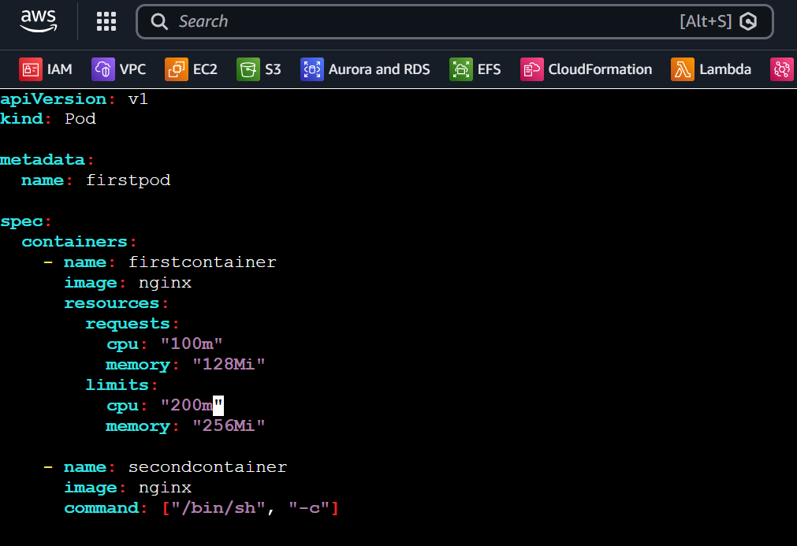

2. Delete the old Pod
kubectl delete pod firstpod
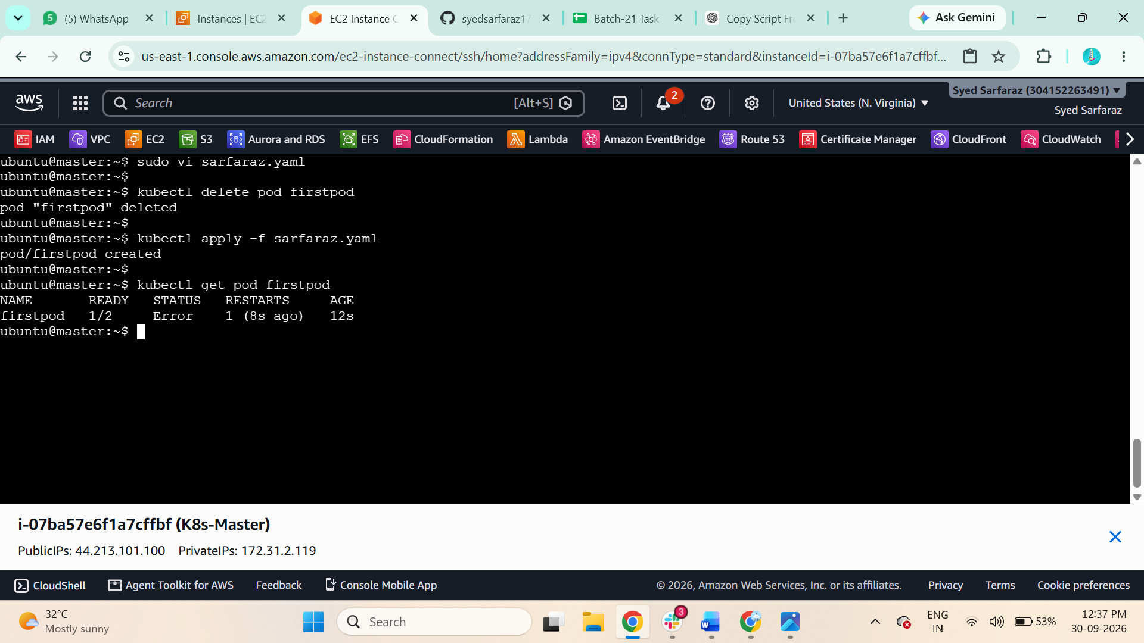

3. Deploy the updated YAML
kubectl apply -f sarfaraz.yaml

4. Check Pod status
kubectl get pod firstpod
Expected:
firstpod 2/2 Running
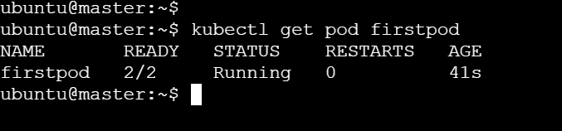

5. Verify resource requests and limits
kubectl describe pod firstpod
Under Containers, verify for both containers:
Requests:
cpu: 100m
memory: 128Mi

Limits:
cpu: 200m
memory: 256Mi
Done.
